# Pre-Modification Prep

Certain existing Ender 3 parts will need to be disassembled and removed, however we do not suggest removing them until all the 3D printed parts are assembled and confirmed to fit. This is to avoid having to reassemble the Ender to print new parts.

## Print the required 3D printed parts

Parts required:

* Central Mounting Teapot
* 2x Barrel Clamps
* Barrel Clamp Jig
* Part Fan Shroud
* Upper Hopper Bracket
* Lower Hopper Bracket
* Limit Switch Extender

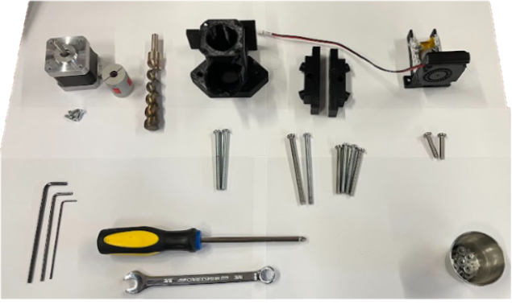

# Press fit pipe into aluminum heater block, screw in nozzle

Parts required:

* 2.5 in steel pipe
* Custom Machined Heater Block

Tools:

* 5/8 drill bit
* File
* Vise

1. Order aluminum block at [Xometry](https://www.xometry.com/?utm_term=xometry&utm_campaign=PB:G%7CNT:SN%7CAN:Manufacturing%7CCN:Branded&utm_source=adwords&utm_medium=ppc&hsa_acc=3789459769&hsa_cam=608070446&hsa_grp=67613041575&hsa_ad=425504589745&hsa_src=g&hsa_tgt=kwd-297018084385&hsa_kw=xometry&hsa_mt=e&hsa_net=adwords&hsa_ver=3&gad_source=1&gclid=Cj0KCQjw0MexBhD3ARIsAEI3WHLvz0pyr79naoRe1LNb88SonjNNj1mLJBc-aEIP4CYGOISpJXHcgTEaAgLtEALw_wcB).
2. Order steel pipe from your local hardware store such as Home Depot, [HomeDepot Steel Pipe](https://www.homedepot.com/p/The-Plumber-s-Choice-1-2-in-x-18-in-Black-Steel-Pipe-1218PBL/307742233). Pipe must be at least 2.5 inches long. Longer pipe is more expensive but gives you more attempts at drilling holes later on. Home Depot offers in-house cutting services, simply contact an employee in the store.
3. Use a ⅝ drill bit to drill out the weld seam inside the 2.5” pipe. This does not normally come with a standard set, a larger drill bit set may need to be purchased.

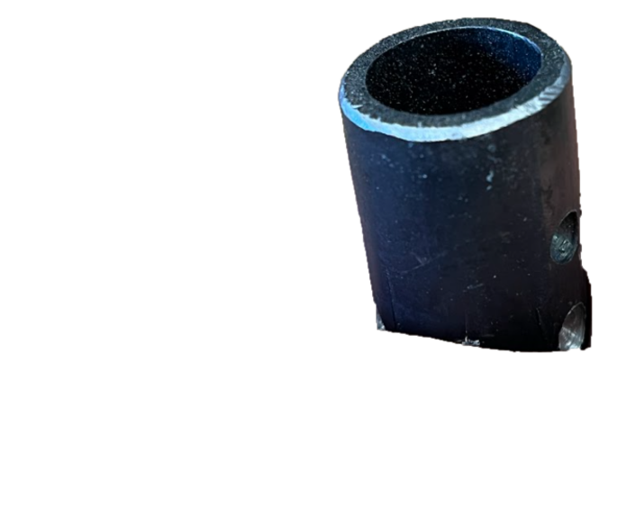

1. File a chamfer onto the cut pipe.
2. Use a tabletop vise to press the steel pipe into the aluminum block. A pipe may be necessary to get extra leverage on the vise. Keep pressing until there is 1.75” sticking out of the block.

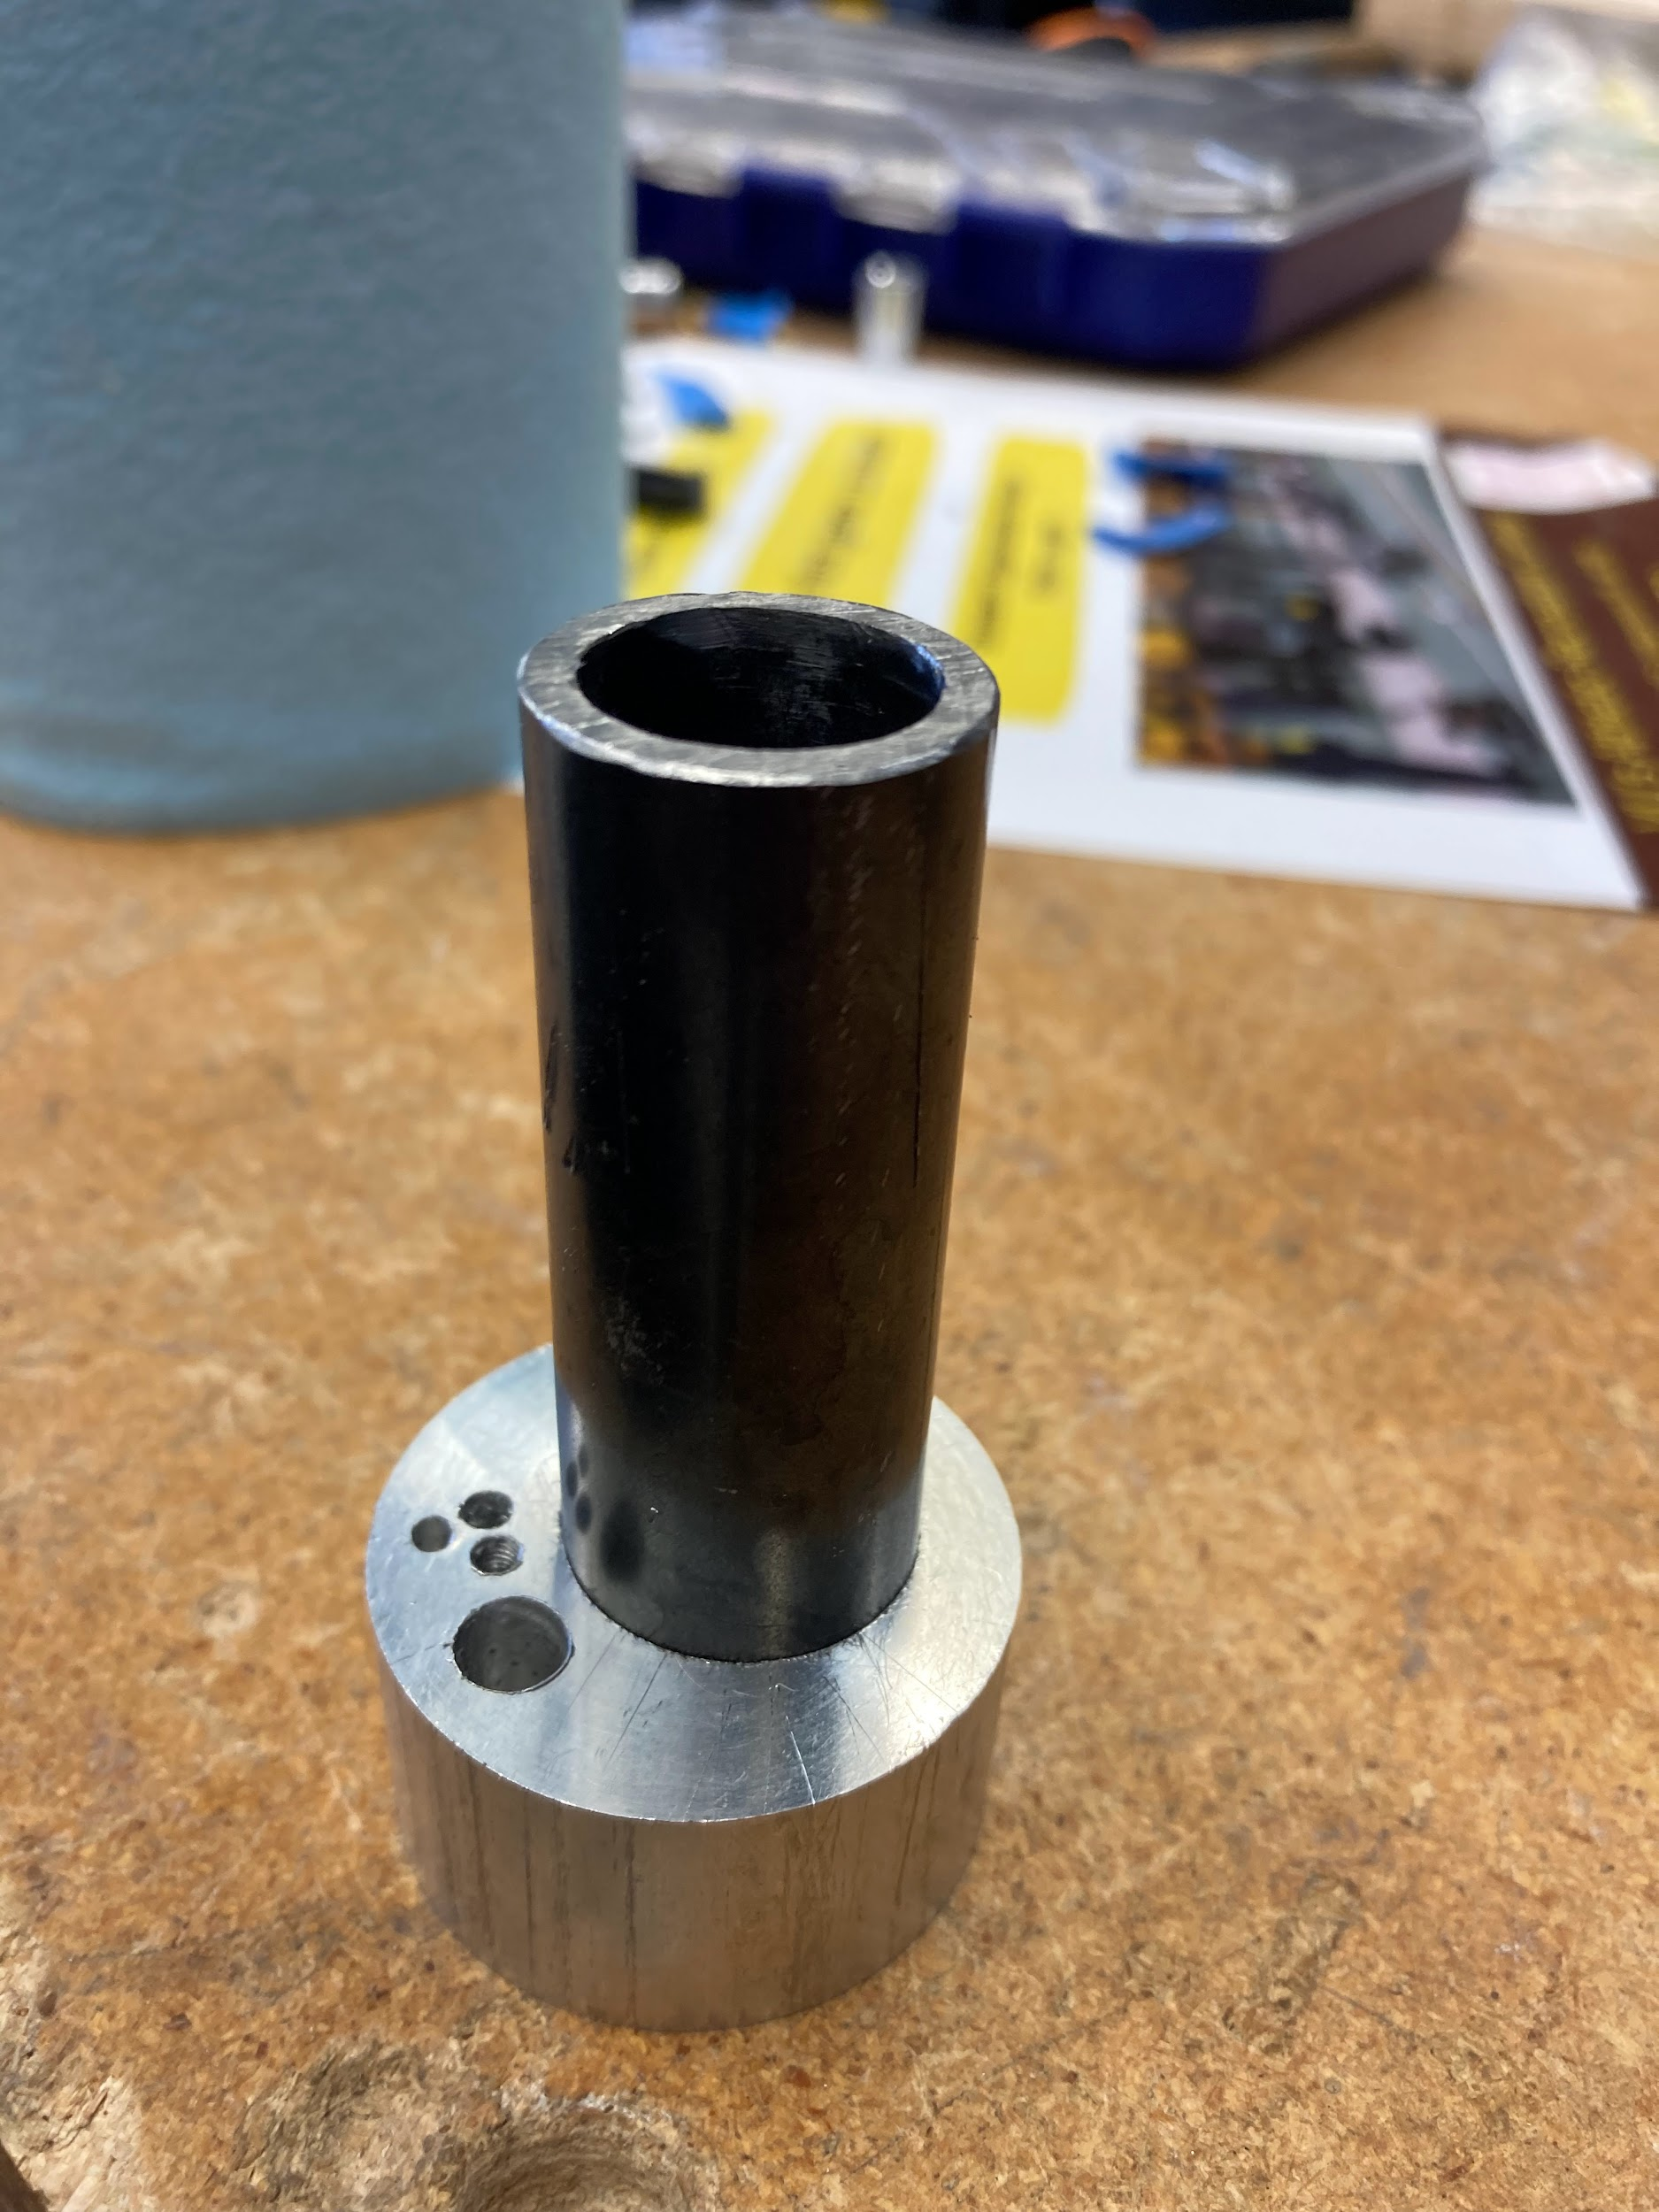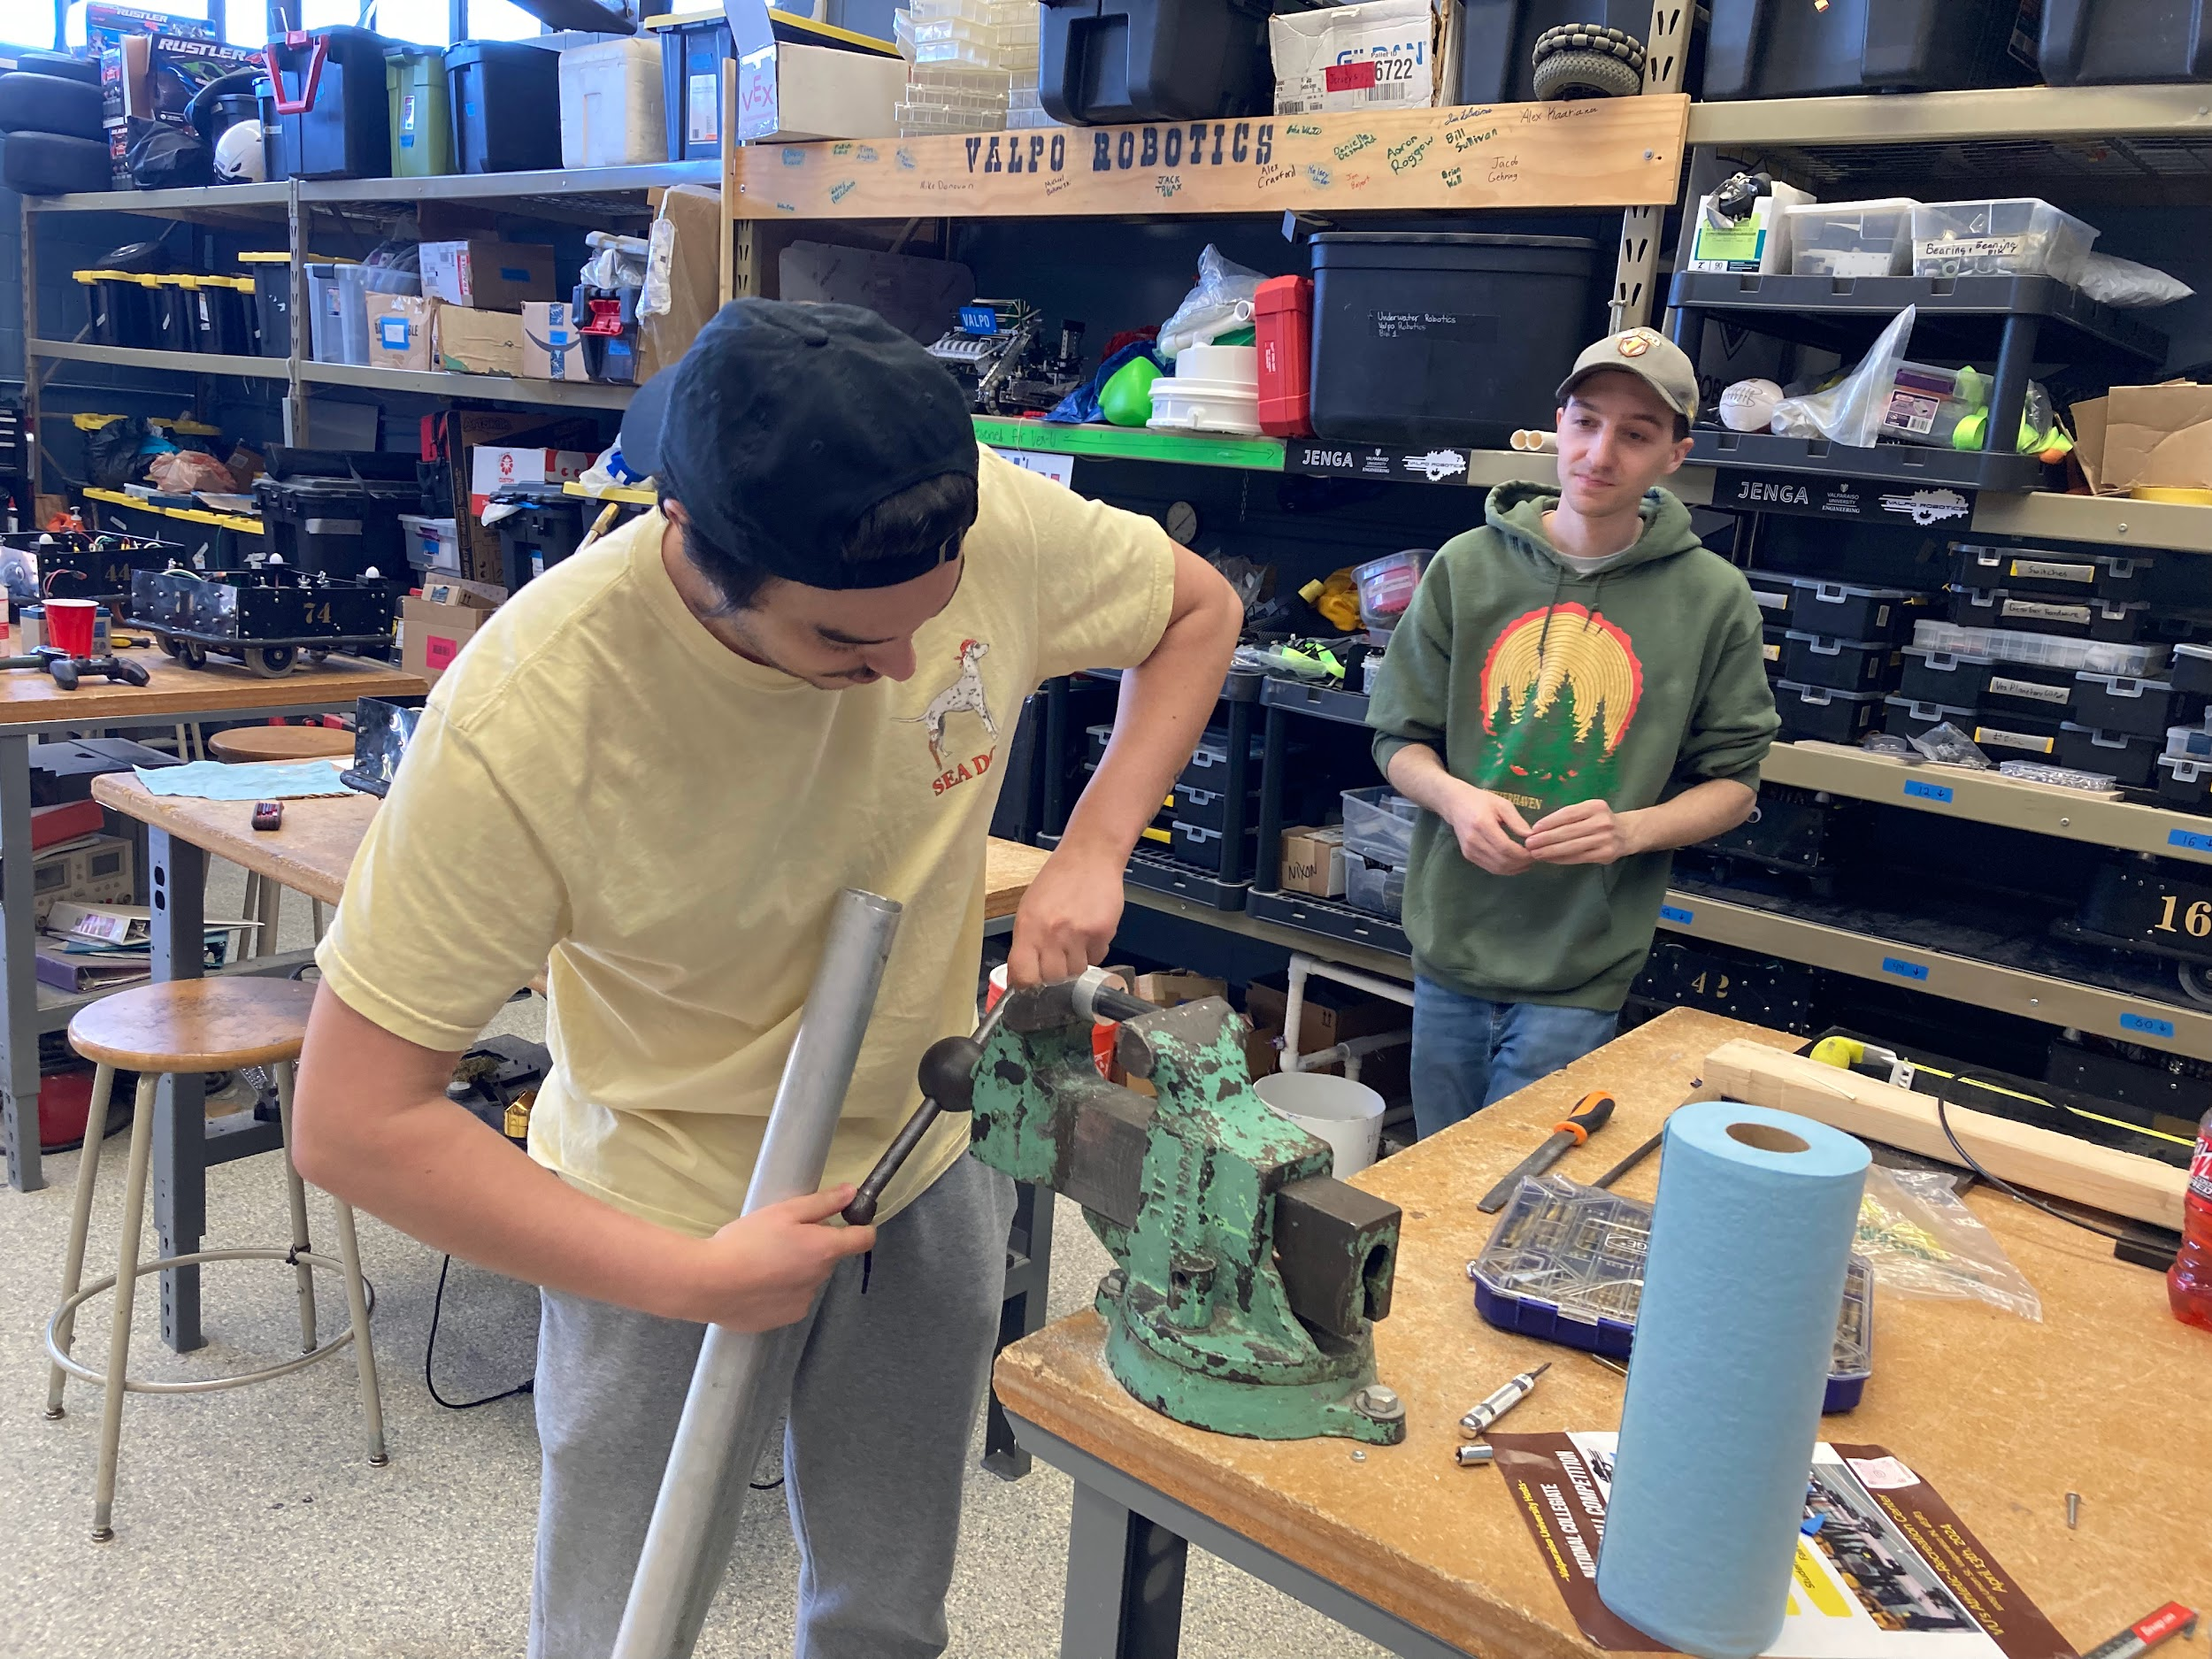

1. Screw in the nozzle bottom of the heater block, in the designated tapped hole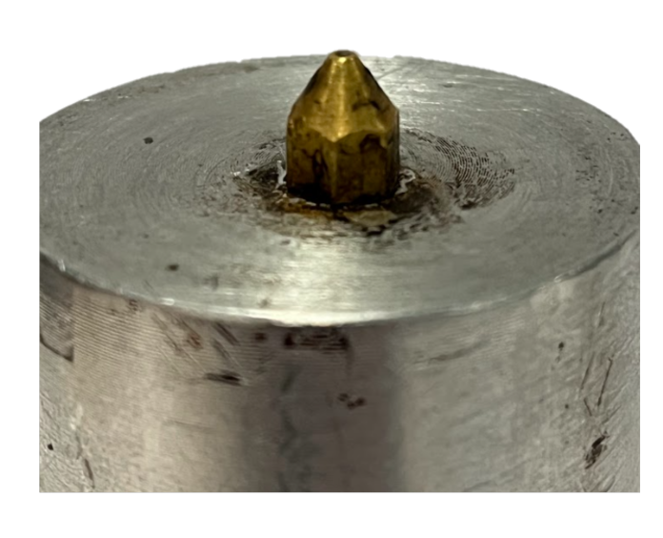

# 

# 

# 

# 

# 

# 

# 

# 

# Barrel Dimples

Parts required:

* Press-fit heater block and barrel assembly
* 3D printed Barrel Clamp Jig

Tools required:

* Electric drill
* 3/16 drill bit
* Center punch or some other marking tool

Assembly Instructions

1. Slide the barrel clamp jig over the barrel about half way
2. Center punch through the four small holes on the side
3. Take off the jig
4. Drill dimples into the four spots with a 3/16 inch drill bit
   1. Make sure the dimples are deep enough that a 10-32 scew can sit in them without moving around

# 

# 

# 

# 

# 

# 

# 

# Insulation step with thermistor

Future iteration might not require this step however due to a slightly oversized heater block, we require insulation to prevent major heat loss and the heater block will heat up faster as well.

Parts required:

* Barrel and Heater Block Assembly from previous step

Tools:

* Measuring Tape
* Shears
* Scissors
* Zip ties

Instructions:

1. Order [Glass Fiber Exhaust Wrap](https://www.amazon.com/Titanium-Exhaust-Motorcycle-Fiberglass-Stainless/dp/B0BYYRFNWK/ref=sr_1_3?dib=eyJ2IjoiMSJ9.oYNAcowuLbw_S71KKp37h5Mi1mIuP7Q1mAFDw6oIhu-ZzvxoQYPvJaIZZVv01lDTqvSRydYR8VtkBSUnSq25-uDV4mbRbtb1QSPvBfUFYEGmorQk75fRFHNnkSKGlW-EDThd-3R4zsRYzSUr27uGKSuzHHNPrkzW0B4pzXSlHQILOCaV2c4ILddK5-NAV8Qokq5L9rGKJeX11yucSuXaP_937ICu6rv2cS0EVNXS0KI.-woQliLFCv-PhS22w7dGwLxTQ1Ek2xmajZ1BH3GmzV8&dib_tag=se&hvadid=580688309263&hvdev=c&hvlocphy=9016213&hvnetw=g&hvqmt=b&hvrand=3056901567993976368&hvtargid=kwd-373848273308&hydadcr=5736_13191251&keywords=exhaust%2Bwrap%2Bhigh%2Btemp&qid=1714579614&sr=8-3&th=1) and [Kapton Tape](https://www.amazon.com/Bertech-Temperature-Polyimide-Yards-Thick/dp/B00HFN67OS/ref=sr_1_1_sspa?crid=N74GJOZY7X0X&dib=eyJ2IjoiMSJ9.h-JRr1e3E1CwxqoJ6uMO2F8AZwNKB-xinvsuztzJVB6ScHmN6Gg3SgQL_iZW_ERXH6pV-1Fva2R6-EVIRDGD1S2H5kasjDIDnJ9LFQpUJzFcvN39albjUotcXoY8Br7T0y7bxH1ky3X8GmkXut4kbURpCXnBMaPXccujS-WefkjJzw26U8ObXS0KSf-b8f-O672JBHcIr1Vrt1iTm8C1rVrY36bqa7H64k8y89QhdV8.jIR8n2zjrIYq16bD7ZSG4vCtPdfzRFRRhA88Cfhpk4c&dib_tag=se&keywords=kapton%2Btape&qid=1714579645&sprefix=kapt%2Caps%2C82&sr=8-1-spons&sp_csd=d2lkZ2V0TmFtZT1zcF9hdGY&th=1) and buy zip ties if you have none available.

WARNING: FOR THIS FOLLOWING PROCEDURE PLEASE WEAR GLOVES AND A MASK!!!!

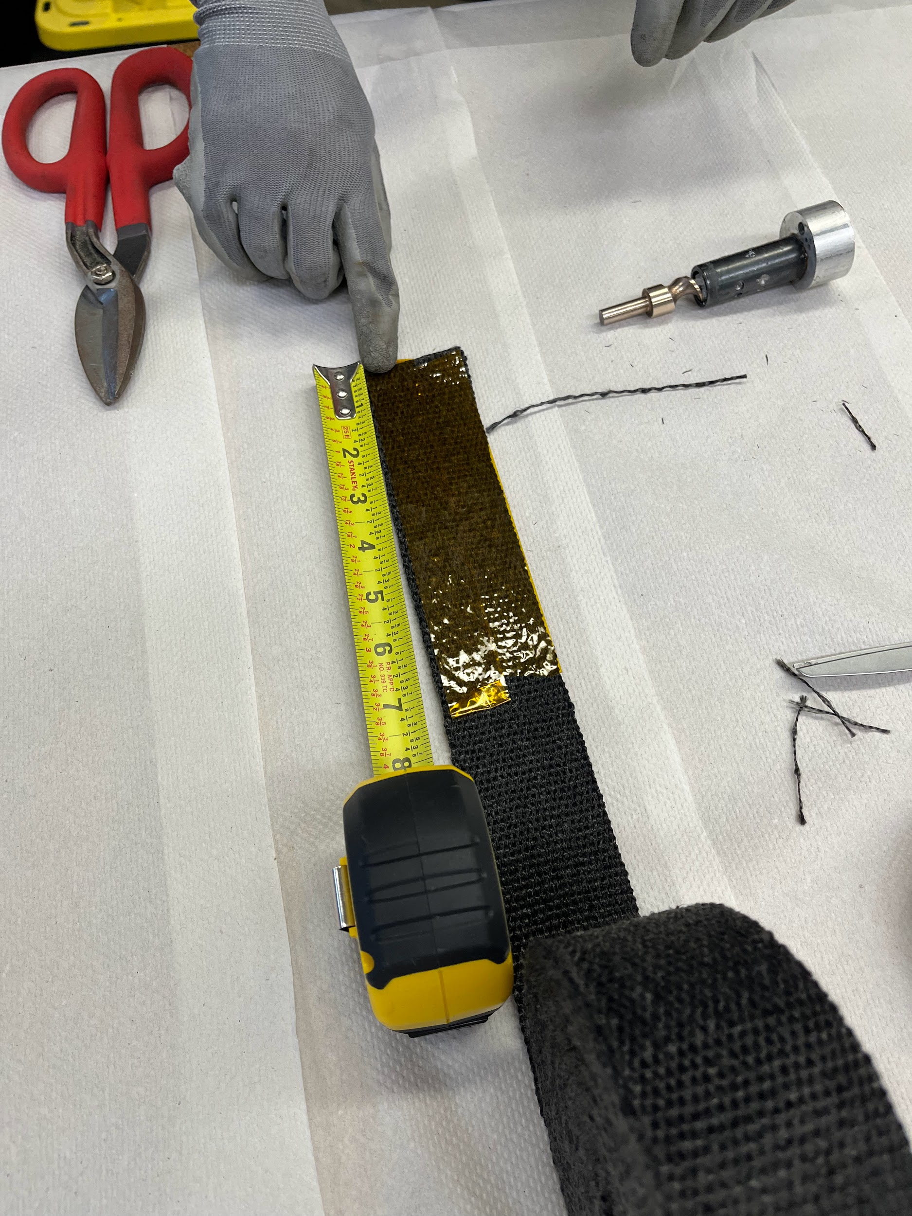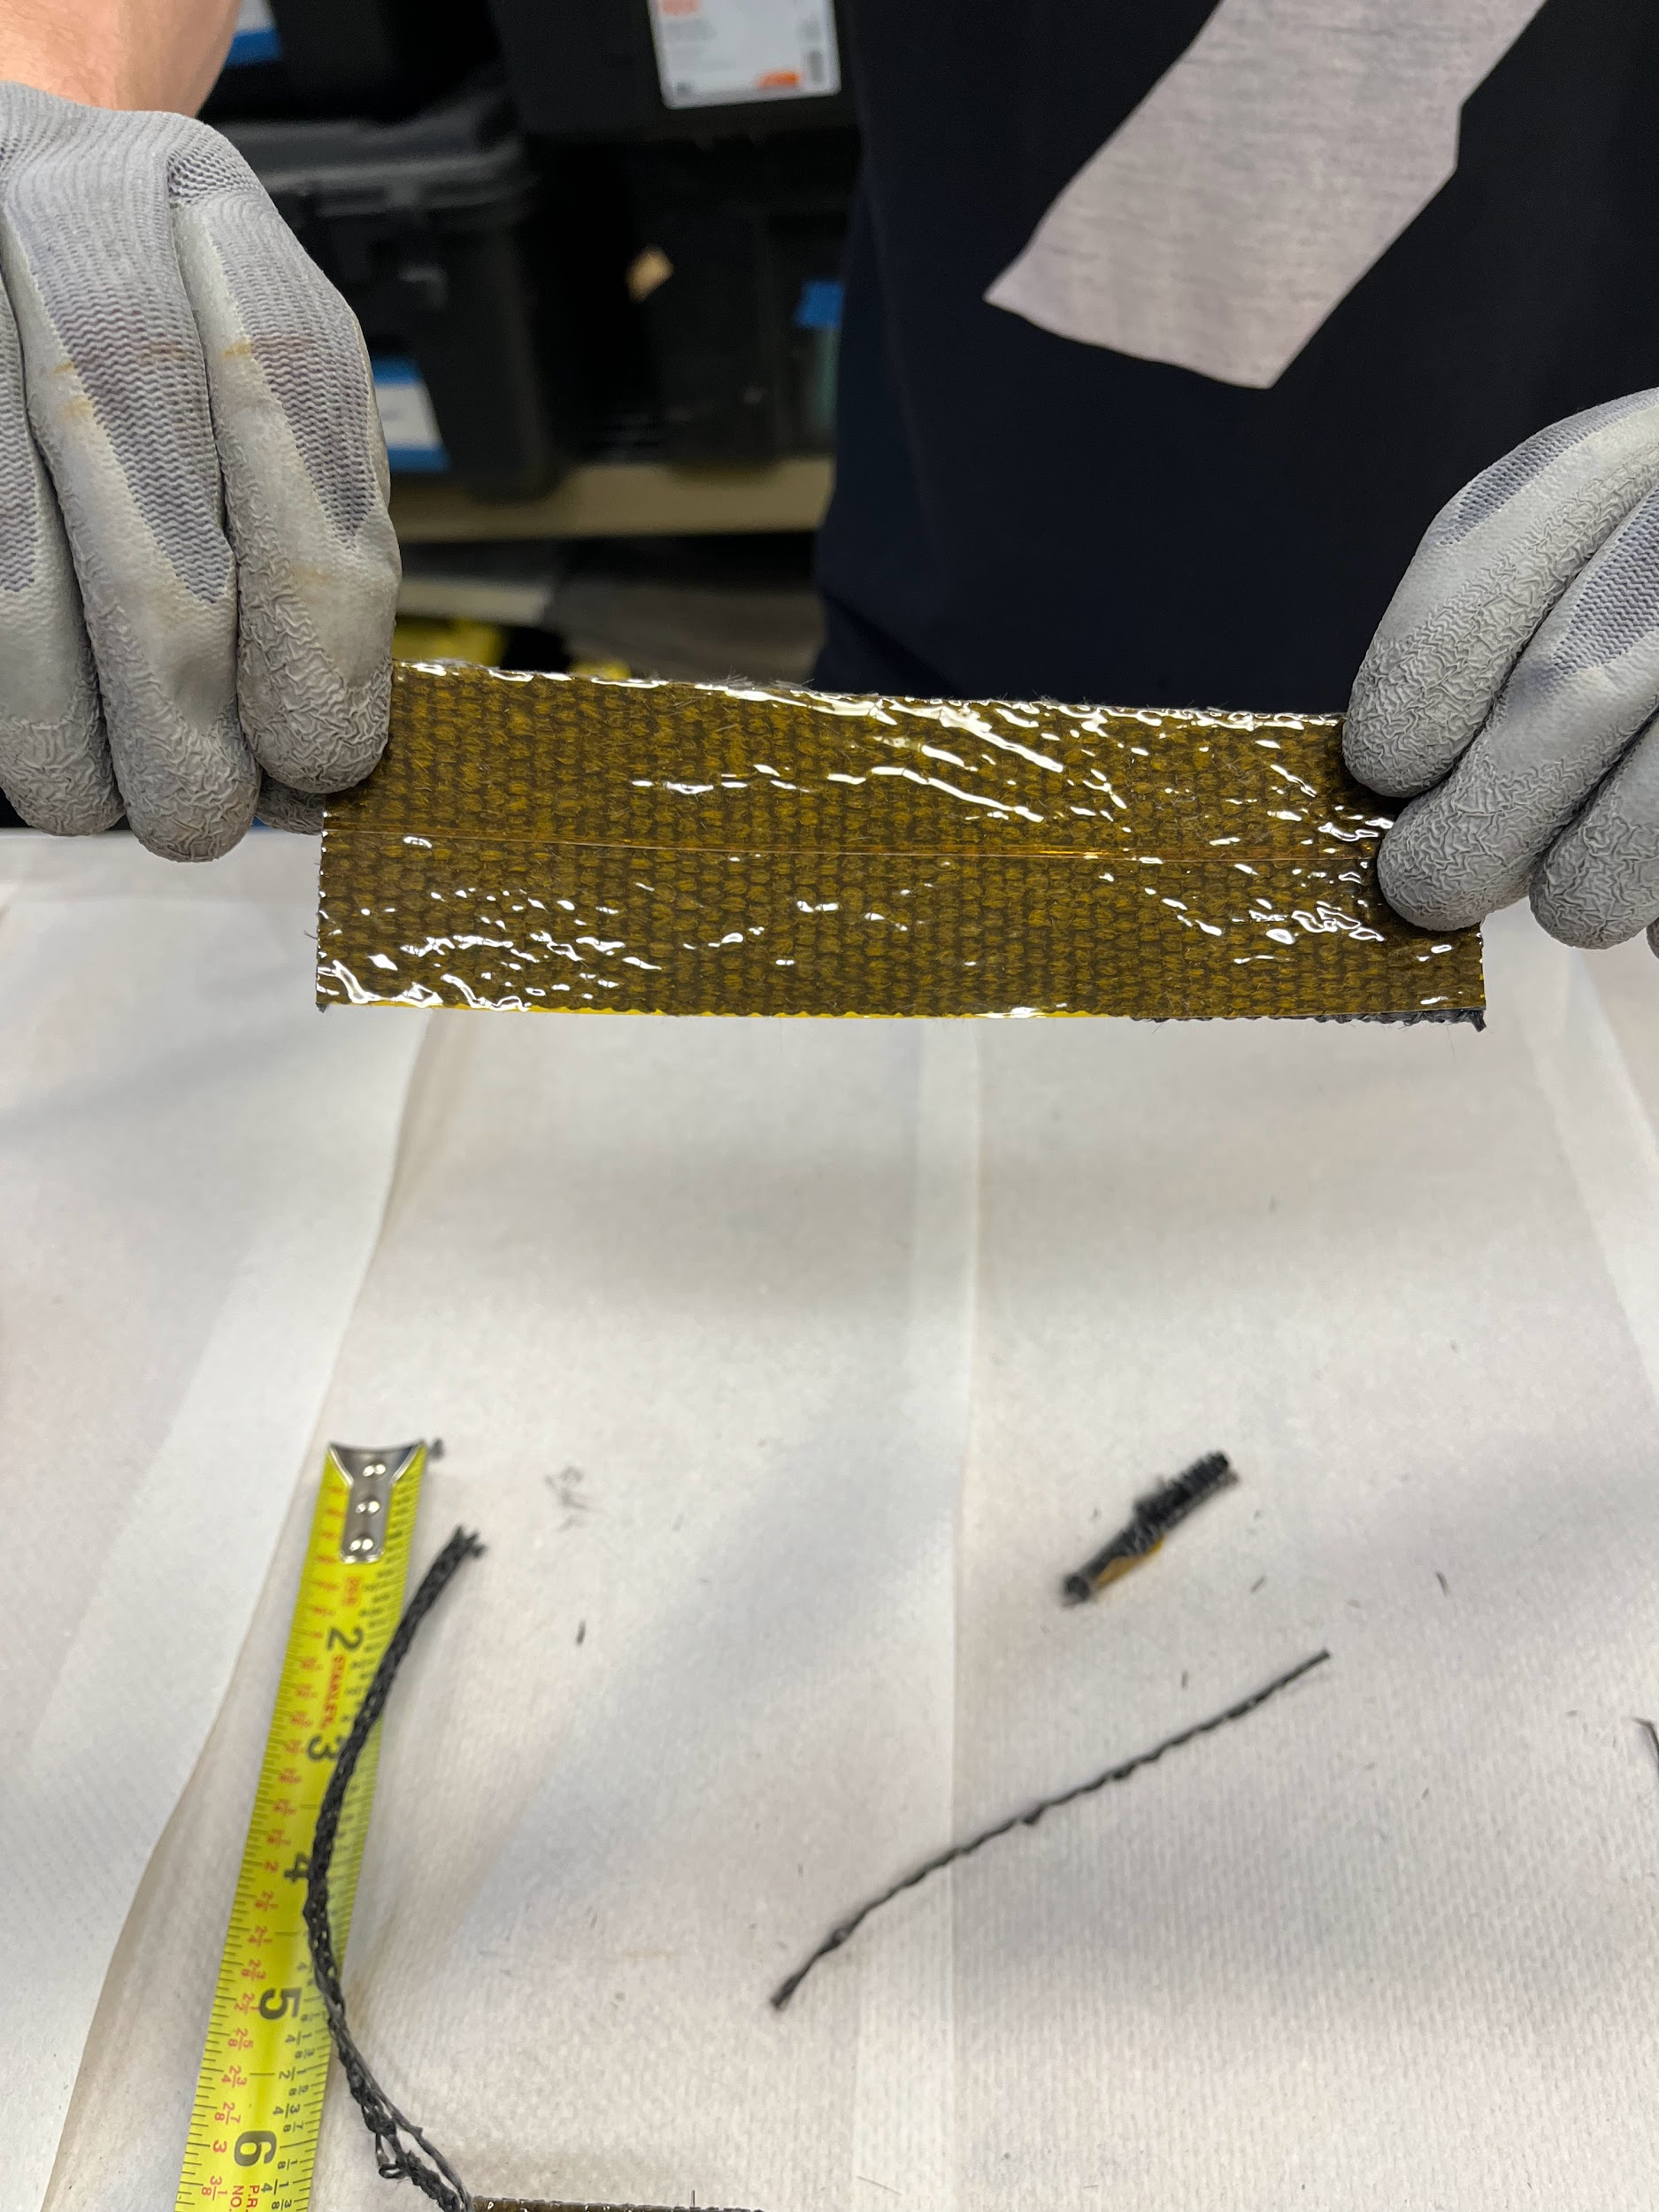

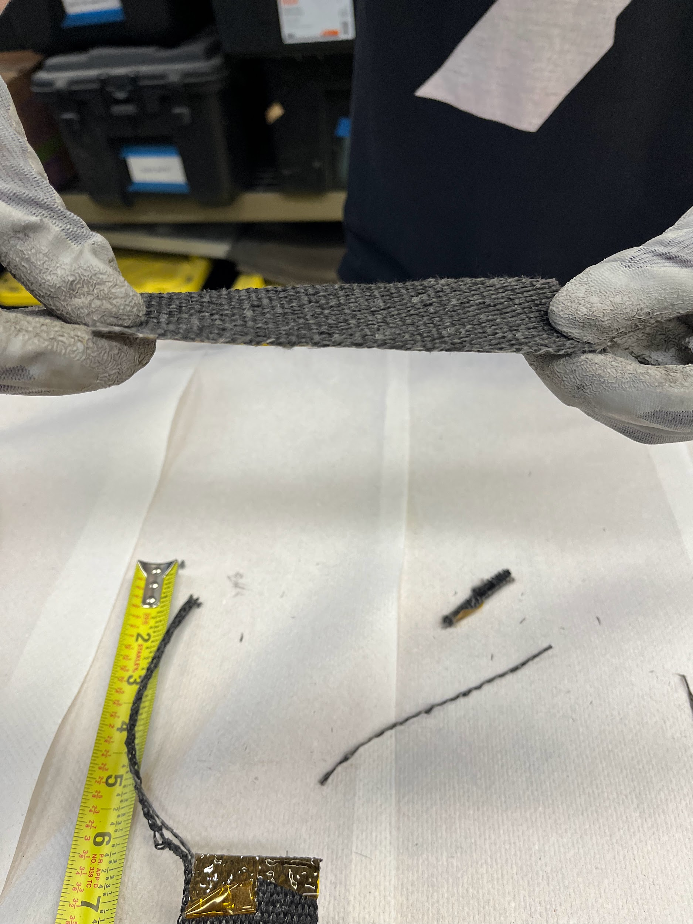

1. Roll out about 7.0 inches of glass fiber before putting kapton tape on both sides of it to make the cutting easier. Then cut the 6.5 inches of the double taped up glass fiber wrap.
2. Cut out a round piece of double taped fiber glass with a small hole for the nozzle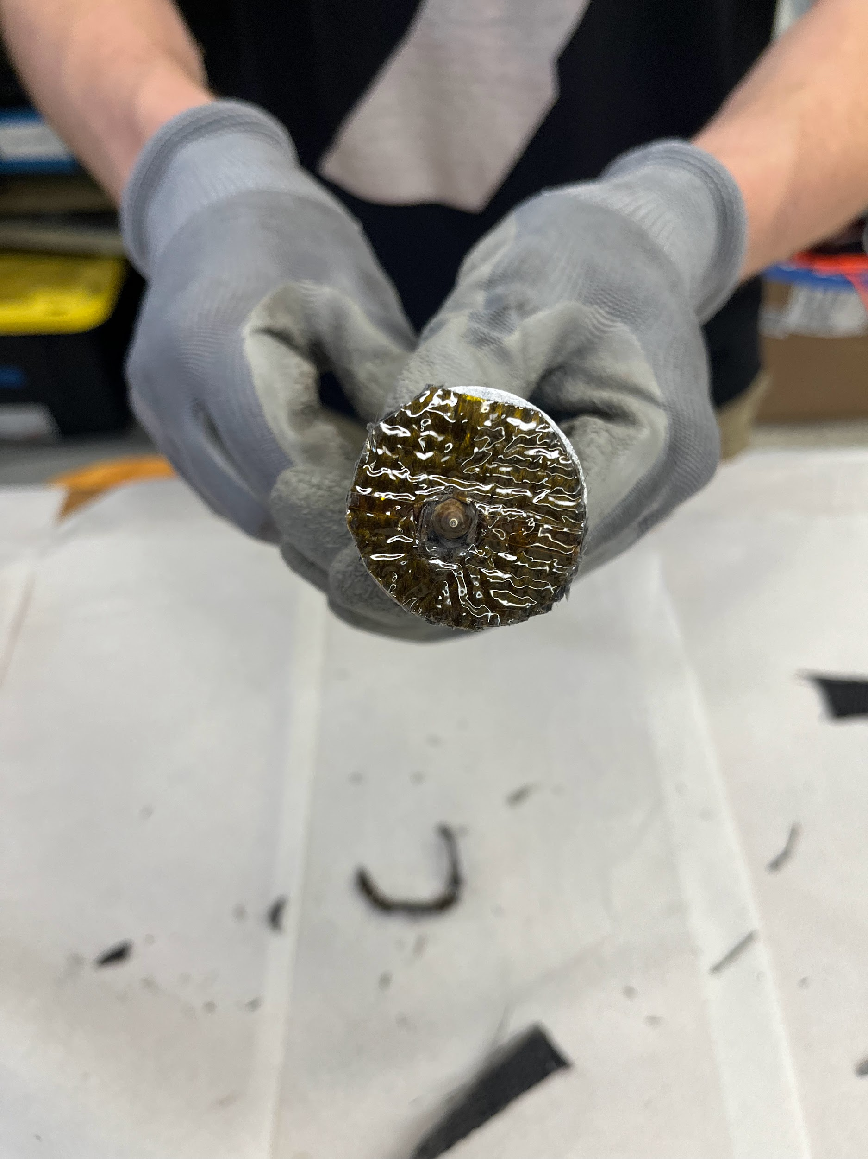
3. Wrap around the glass fiber around the heater block and fixate it with zip ties.
4. Tape the bottom piece to the heater block with kapton tape.
5. Screw in the thermistor into the designated tapped hole and hold it in place with more kapton tape
   1. Note: Using a [screw-in thermistor](https://www.amazon.com/Thermistor-Upgrade-Printer-Extended-Extruder/dp/B0CMCLXQ87/ref=sr_1_1_sspa?dib=eyJ2IjoiMSJ9.hiYSsNqhgZq4Pu-hSepWg0Fln2_IBk23dBGUgUERQYRvTWmO7OI1k923Fk4FlbxR5D1t175LM7PGLk4nu2SbsaOrl6T87126JKwSqu_b6buxD5ajUA5DDP4BOesR8rC_rSGhcq_KmlwQDvuKnbrOcO4kV8aS-eg7EYqdeFo6672wzBEPsNmDERvAPNQiuvjehP7ZVzu81w0xx-P7e9y-2cZhrg3unv4IF2sRdrR5ZvI.eU5XRlE1KBTQoqWH9lG2P-ECW8mEcObFpcdnwxHhVyI&dib_tag=se&keywords=screw%2Bin%2Bthermistor%2Bfor%2Bender%2B3&qid=1714766268&sr=8-1-spons&sp_csd=d2lkZ2V0TmFtZT1zcF9hdGY&th=1) might simplify the process since we had some issues with the regular thermistor.

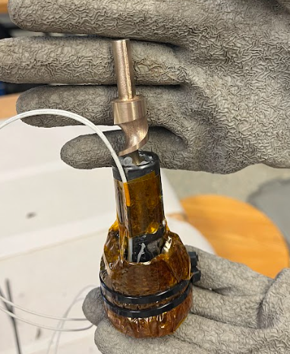

# Extruder Assembly Instructions

## Stepper Motor Coupling

Parts required

* Stepper motor
* Central mounting teapot
* Extrusion screw
* Coupler
* O-Ring set
  + Size 14
  + Size 17

Tools required

* 2.5mm Allen key
* 3mm Allen key

Assembly Steps

1. Tighten the coupler over the stepper motor shaft, then attach the extrusion screw to the other end of the coupler.

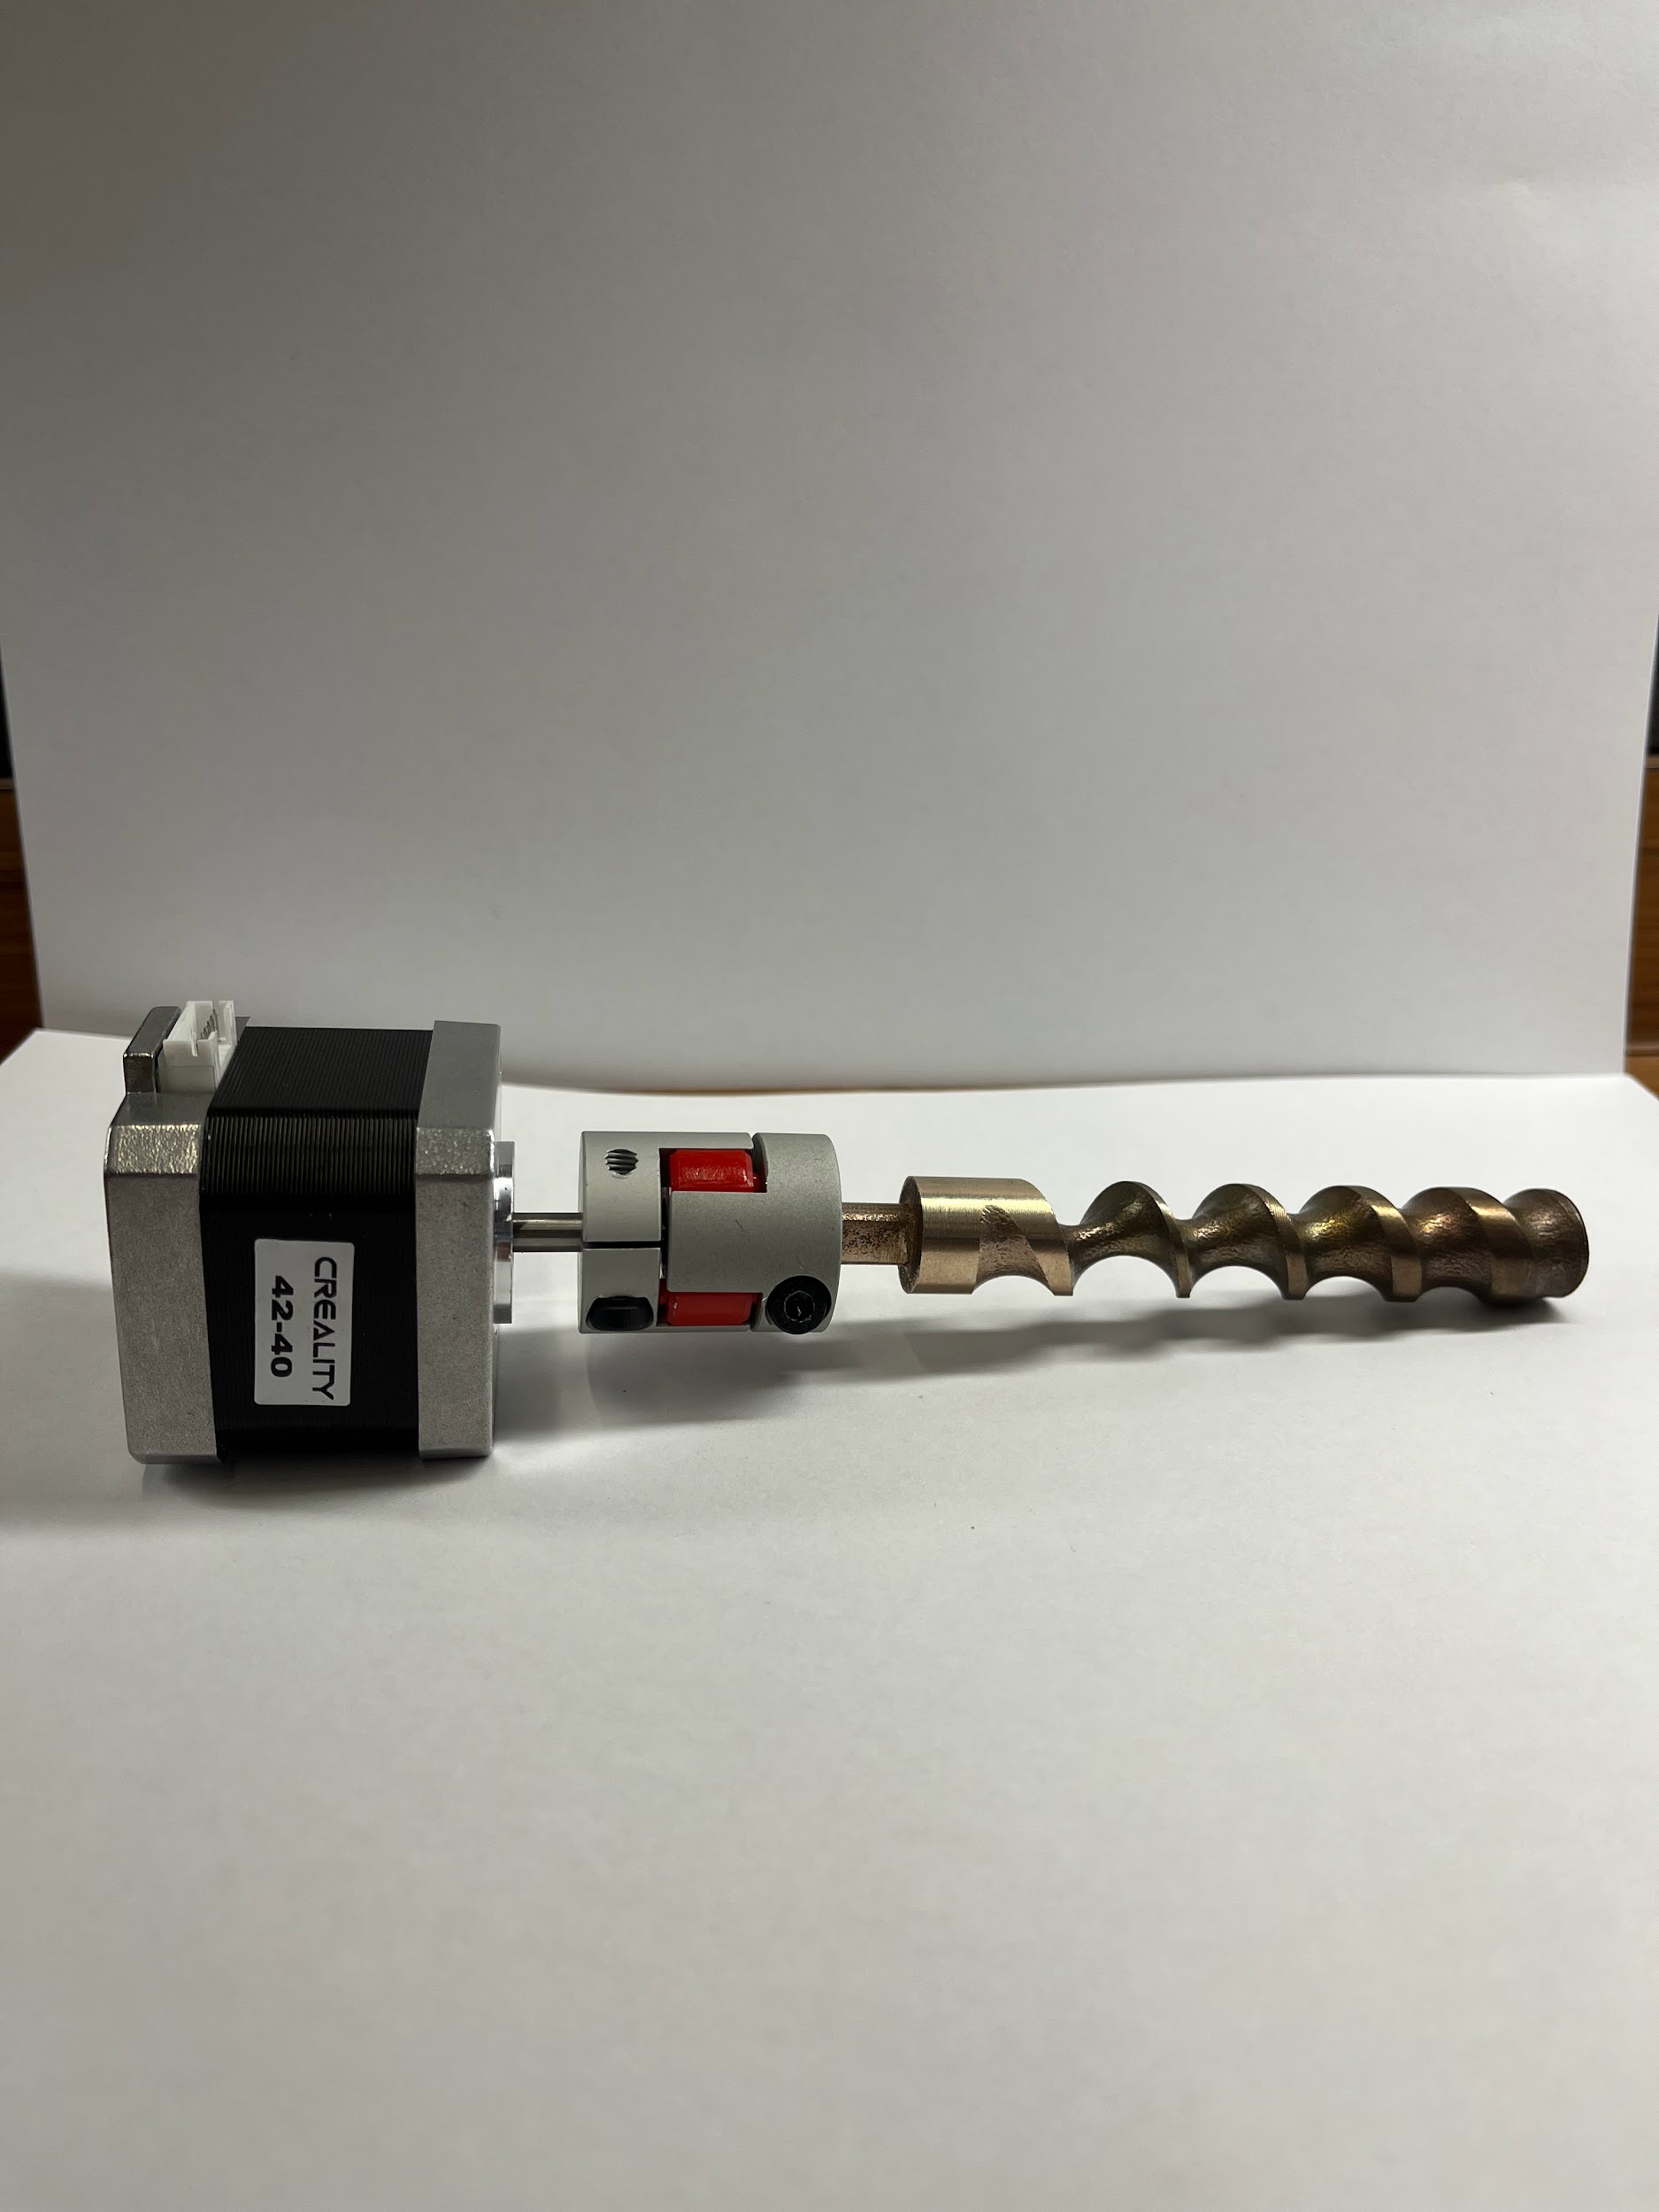

1. Insert the entire stepper-coupler-screw assembly into the upper hole of the Central Mounting Teapot, ensuring that the stepper motor’s wire port is facing opposite of the Teapot’s spout.
2. Insert the size 14 rubber O-ring into the bottom of the teapot followed by the size 17 O-ring.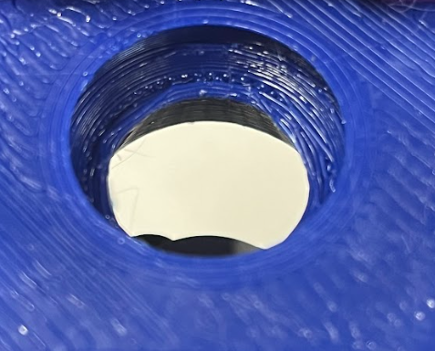

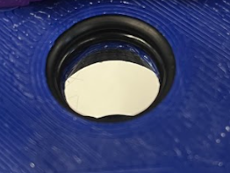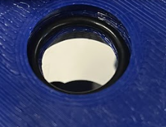

1. Secure the stepper motor to the top of the Teapot using the four holes located on each corner of the stepper motor and the screws included with the stepper motor.



## Part Fan Attachment

Parts required:

* Teapot assembly
* 3D printed part fan shroud
* 2x 1in 10-32 screws
* 2x 10-32 hex nut
* Creality part fan
  + Including the 4 M2 screws

Tools required:

* Philips screwdriver
* 1.5mm Allen key
* ⅜ wrench or crescent wrench

Assembly Steps

1. Attach the part fan to the 3D printed fan shroud.
   1. Holes may need to be drilled in the 3D printed part to fit. Use a 5/64 drill bit.
2. Screw the 3D printed fan shroud onto the Teapot assembly using the holes in the front of the Teapot and the 1in screws.

See images on the next page.

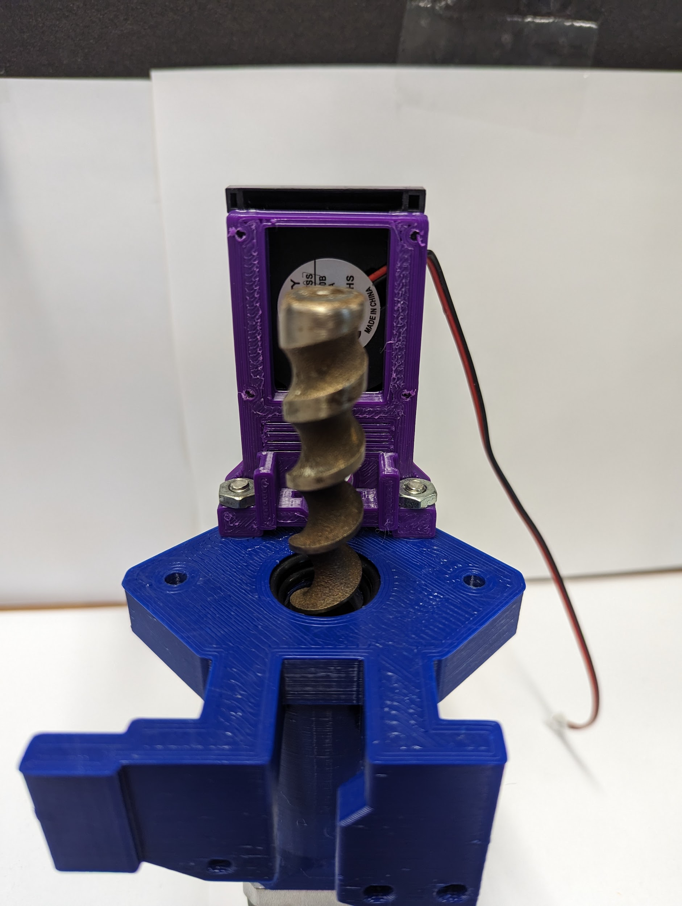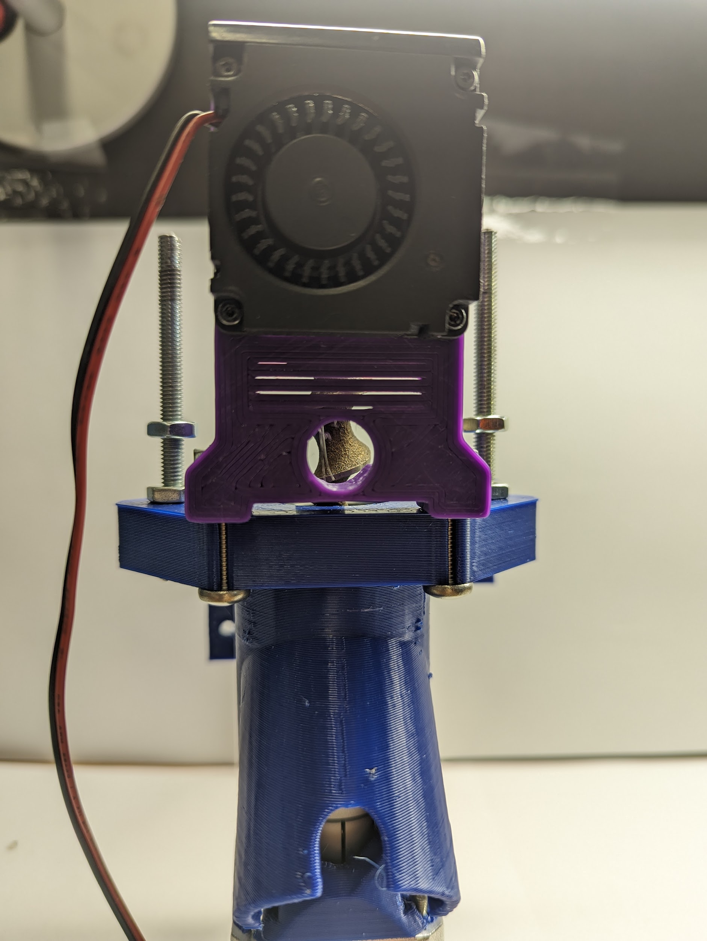

## Barrel Clamps

Parts required:

* Teapot assembly
* 2x 3D printed barrel clamps
* Rubber o-rings
* 4x 2in 10-32 screws
* 2x 2.5in 10-32 screw
* 4x 3in 10-32 screws
* 16x 10-32 hex nuts

Tools required:

* 3/8th wrench or crescent wrench
* Philips Screwdriver

Assembly Steps

1. Install a 2.5” 10-32 screw on both sides of the Central Mounting Teapot. Secure them using a 10-32 hex nut.
2. Thread on a second 10-32 hex nut on each screw ~¾” above the first hex nut.



1. Install one hex nut on a 2” 10-32 screw, threading it down near the head of the screw.
2. Insert screw into barrel clamp.
3. Add a second hex nut, threading it on ~¼”.

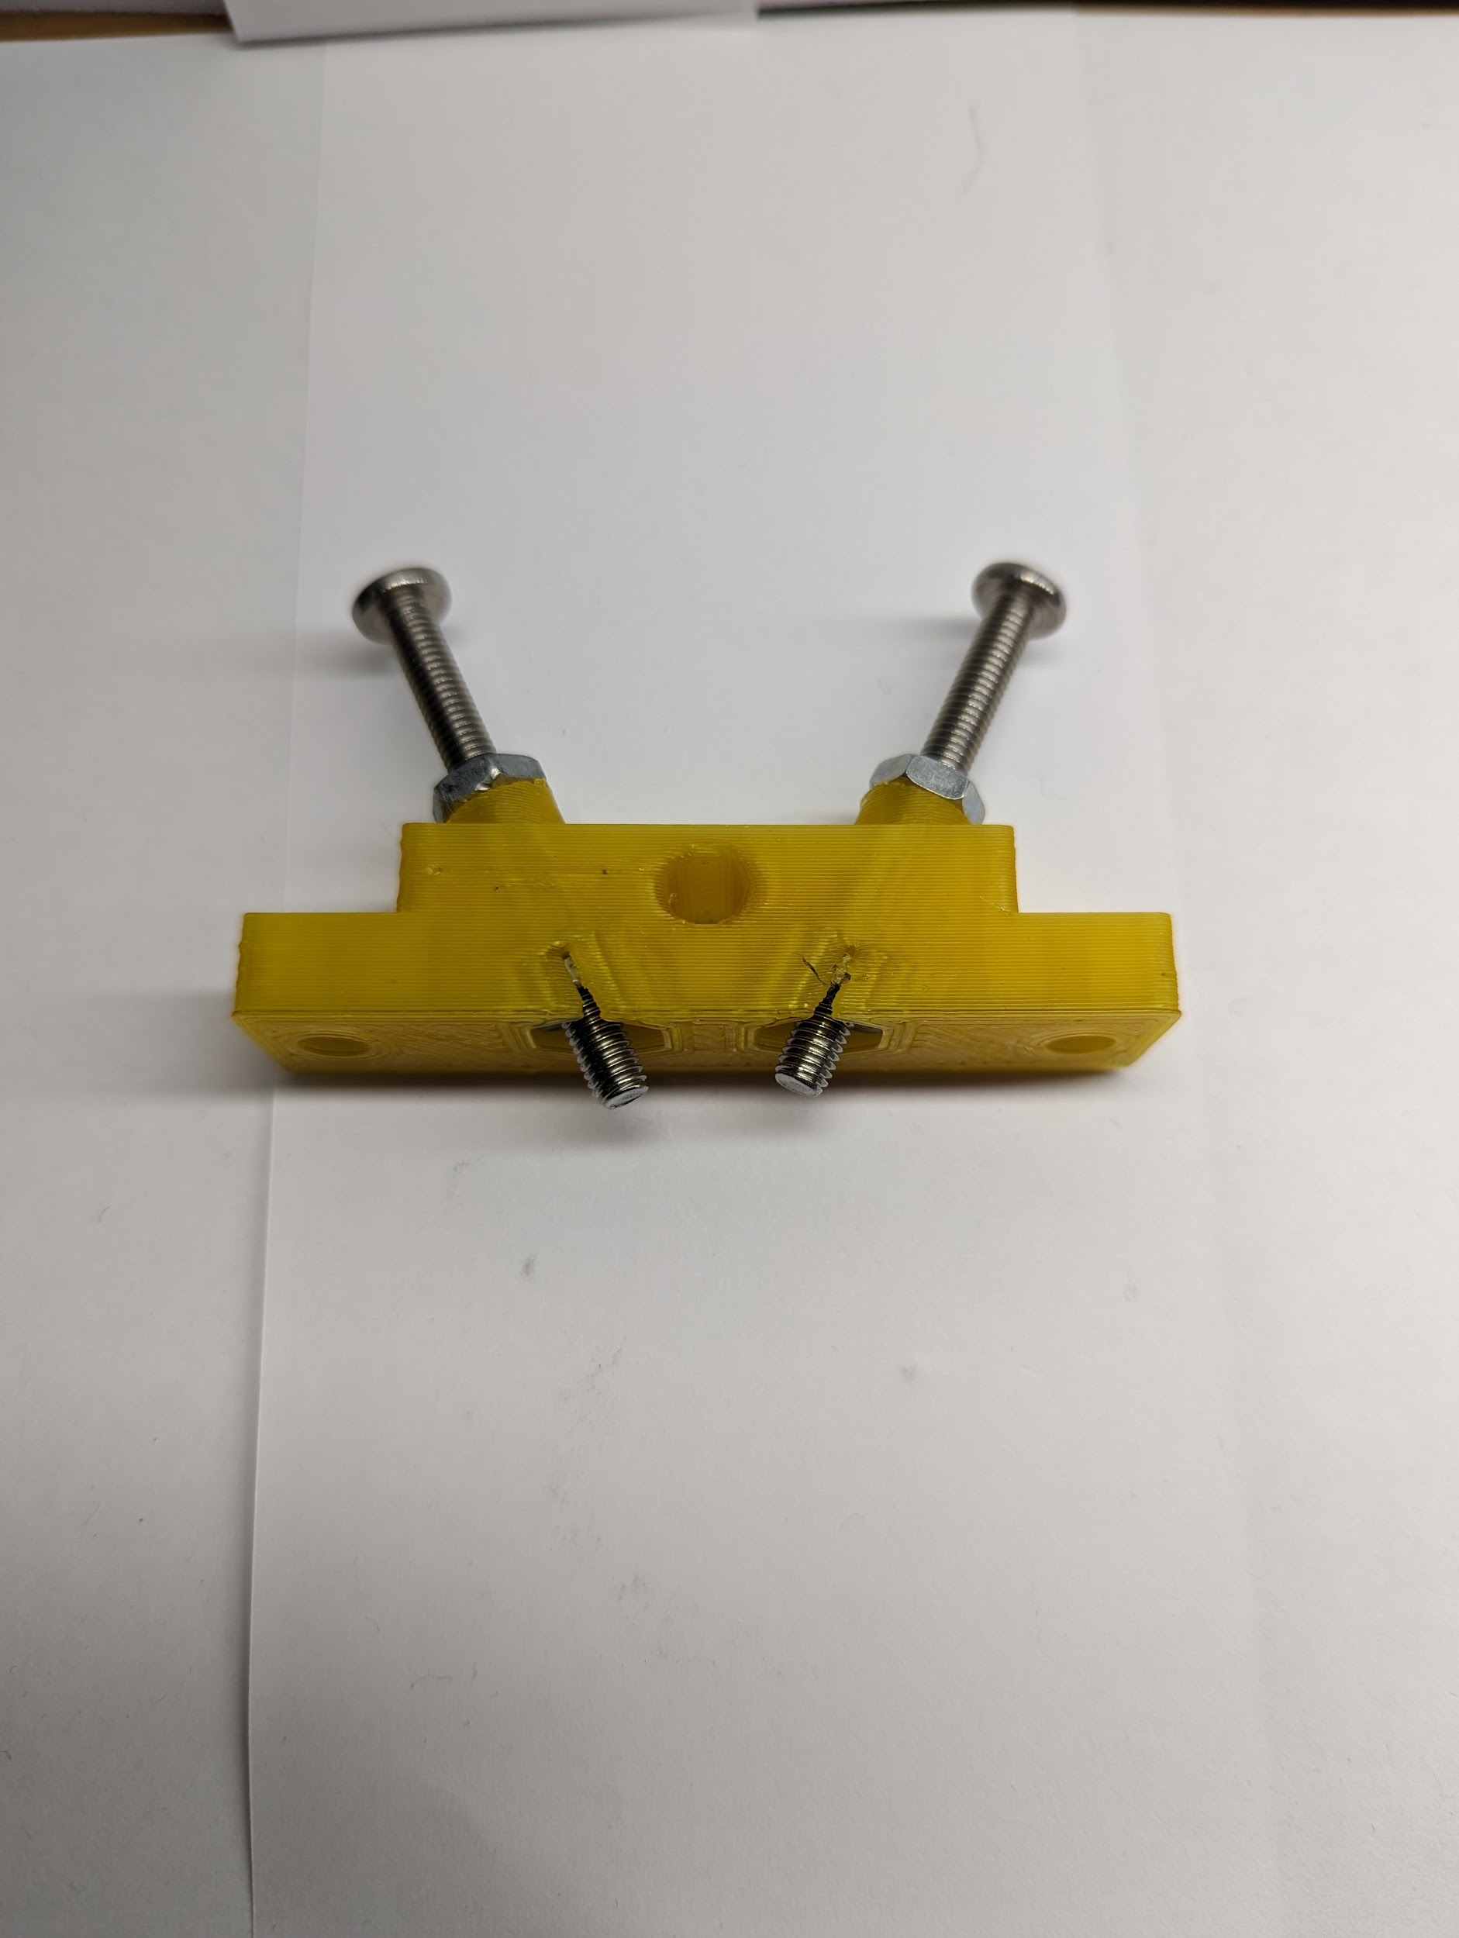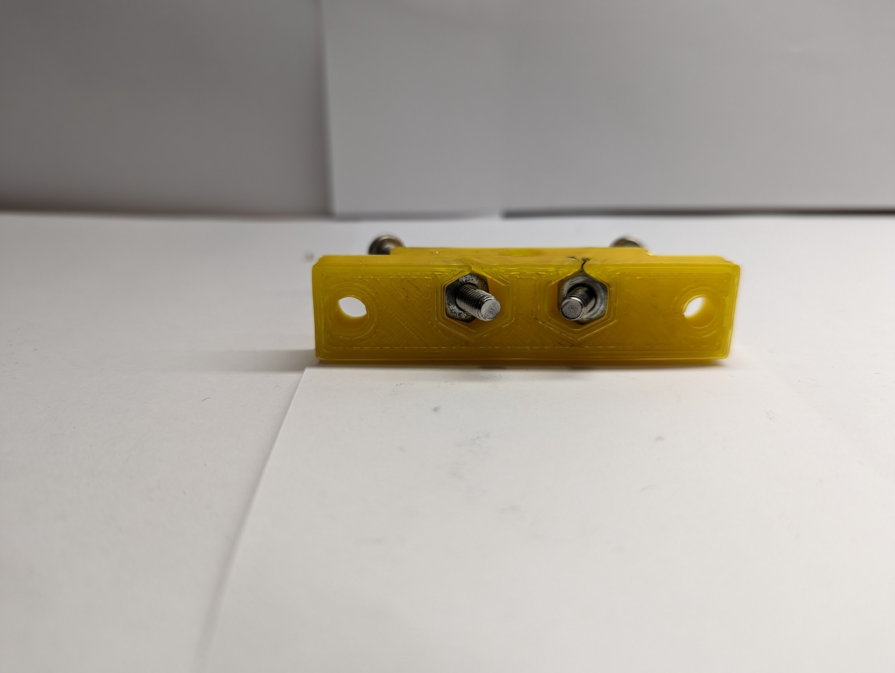

1. Pull hex nut into the barrel clamp so it sits flush inside the clamp.
2. Tighten the first hex nut down against the barrel clamp. Screw should be secure inside the barrel clamp now but loose enough to turn still
3. Repeat for each of the three remaining screws.
4. Slide barrel clamps onto the 2.5” 10-32 screws and secure with hex nuts but don’t tighten
5. Install the two 3” 10-32 screws into the outer holes of the barrel clamp and secure with the hex nuts, but don’t tighten. The screws should face in opposite directions



## Barrel Fixation

Parts required:

* Teapot assembly
* Pressfitted Barrel and Heater Block Assembly
  + Insulated Heater Block if necessary

Tools required:

* 3/8th wrench or crescent wrench
* Philips Screwdriver

Assembly Steps:

1. Slide the barrel assembly over the screw with the hole for the heater cartridge facing to the back plate of the teapot.



1. Slightly tighten in the 4 clamp screws so they get placed into the dimples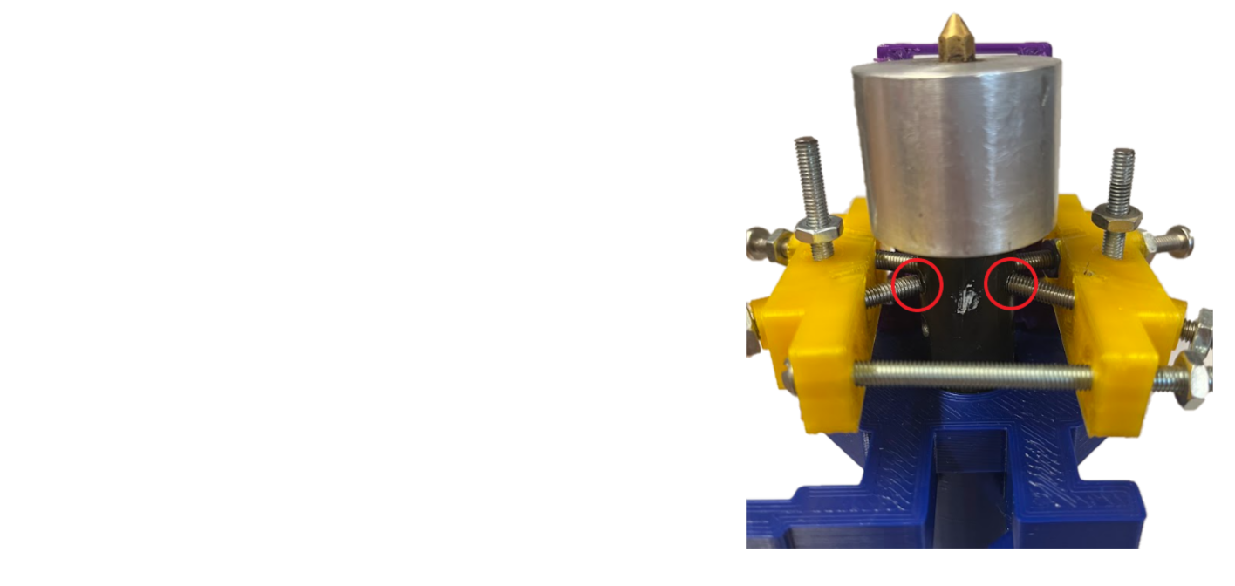
2. Once the screws are in the dimples, start fixating the clamps vertically by adjusting the nuts below and above the clamps. The goal of this step is to line up the 4 clamp screws horizontally.

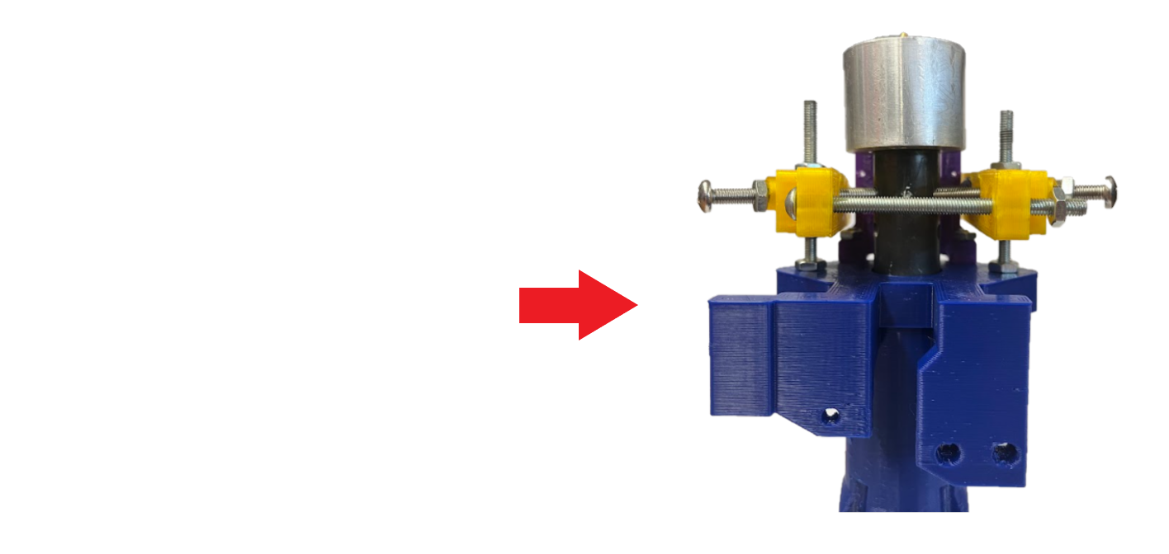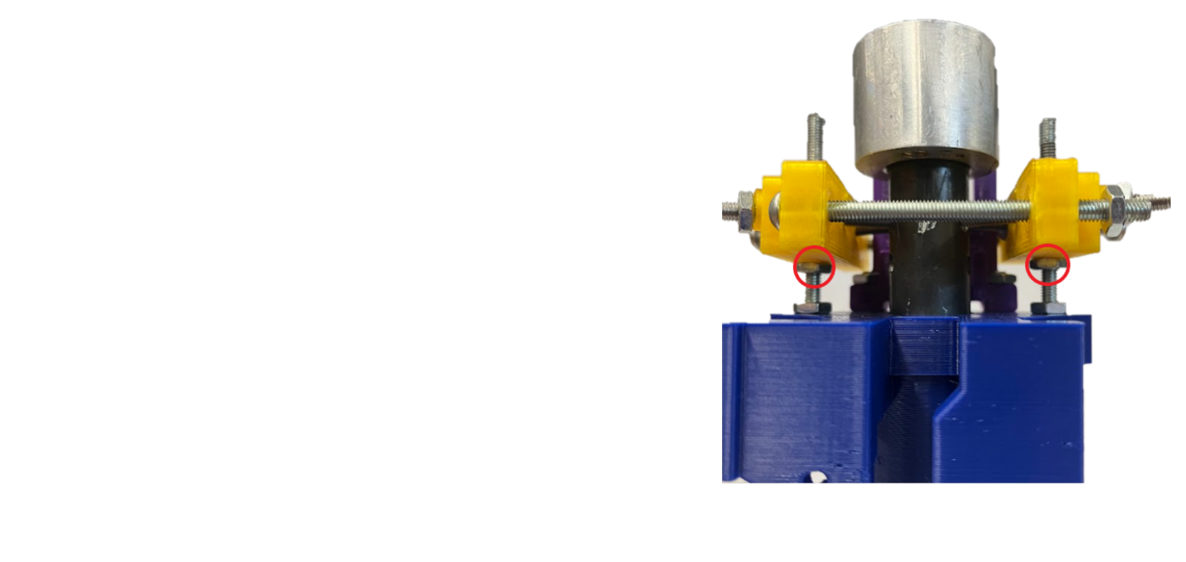

1. Loosen up the 4 clamp screws a little bit before tightening the two 3” screws starting with the one next to the fan shroud. Tighten it until the barrel clamp hits the fan shroud. Next tighten the other 3” screw until both barrel clamps are parallel to each other. 

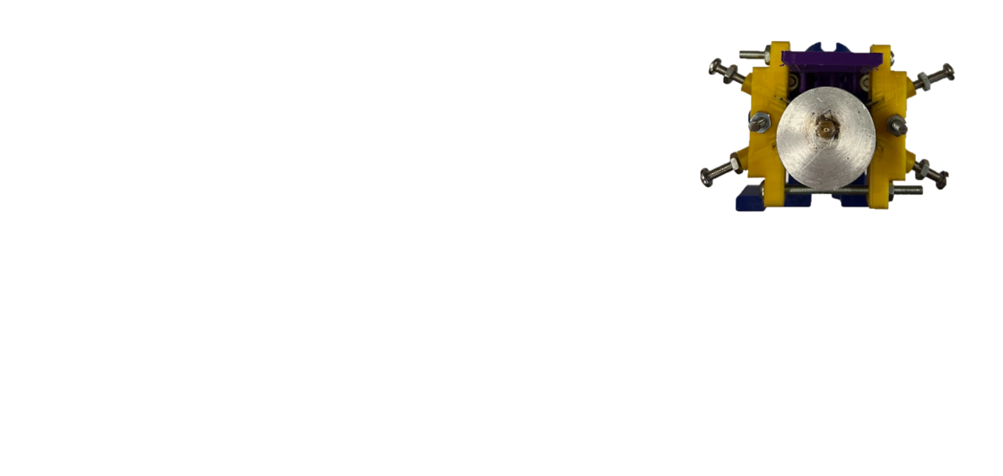

1. Now tighten up the 4 clamps screws and again including tightening the bolts on all four.

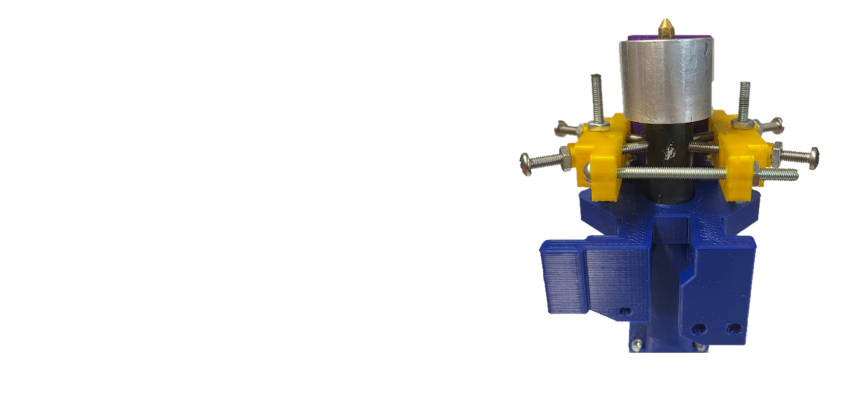

# Disassemble Unneeded Ender Parts

Disassemble the:

* Extruder hotend module
* Extruder stepper motor system
* Either purchase a second stepper motor, or remove the gear from the existing stepper motor.

# Hopper Assembly

Tools needed:

* Knife
* Scissors
* Philips Screwdriver
* Crescent Wrench
* Ender 3 Allen Key

Parts required:

* Standard bottle with 1 inch cap, such as a soda liter bottle or 20 oz plastic bottle.
* ~ 2 feet of 1 inch corrugated tubing
* 1x Zip Tie
* Upper 3D printed Hopper Bracket
* Lower 3D printed Hopper Bracket
* 4x 8/32” screws x ¾” long
* ¼-20 24 inches long
* 4x ¼-20 nuts

Steps:

1. Install the upper hopper bracket onto the threaded rod by screwing on one nut, sliding the printed part above that, then screwing another nut on top as shown below.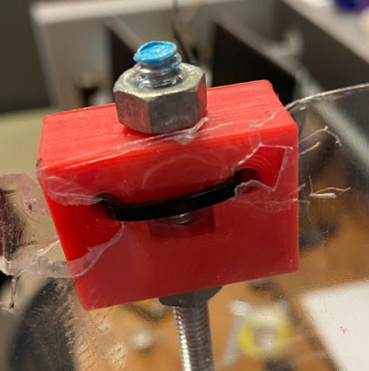
2. Perform a similar installation on the lower hopper bracket to attach it to the threaded rod.
3. Remove the extruder stepper motor and extrusion system from the lead screw bracket.

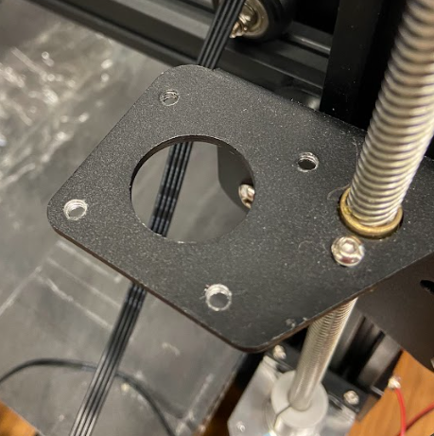

1. Attach the lower hopper bracket to the lead screw bracket using the 8/32 bolts. 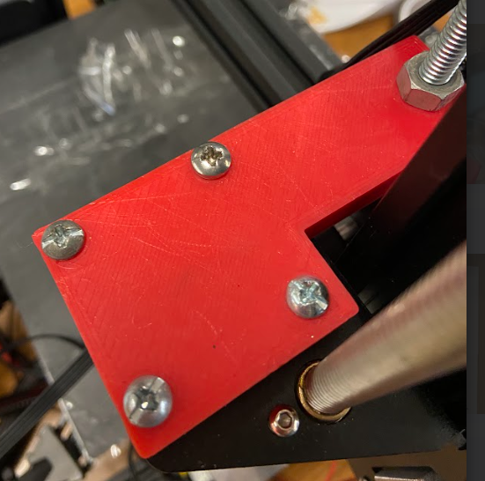
2. Cut bottom of bottle off
3. Punch 2 small holes in bottle near the severed portion that line up with the Upper Hopper Bracket.
4. Secure bottle to Upper Hopper Bracket using a zip tie.
5. Remove bottle cap and feed tube over cap.
6. Insert corrugated tube in Central Mounting Teapot.

# Installing the Limit Switch Extender

Parts required:

* Limit Switch Extender

Steps:

1. Slide Limit Switch Extender onto existing plastic bracket.

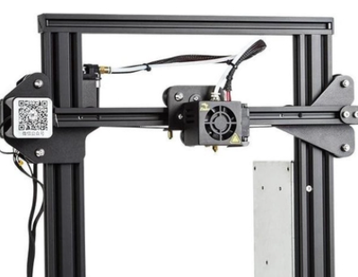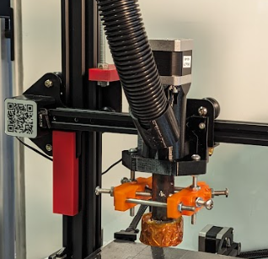

1. Adjust height of bracket as needed to ensure nozzle is perfectly aligned with bed when Limit Switch is activated by the Limit Switch Extender. This will account for any variability in assembly.

**NOTE: This bracket should be tight enough that it does not fall off during operation.**

# Printer Settings

Adjust these printer settings through either the control panel or in the slicer. If the settings are changed through the control panel they might reset at the beginning of the printing process, beware of that.

Speed: 65

Acceleration: 375

Jerk (VX and VY): 6

Flow: 50

Fan Speed: 5% (for remote fan). Ideally the nozzle fan runs at 100% speed, rewiring might be necessary.

This settings can be changed. IT’S ENCOURAGED!